North-West Financial Broker

Account: 110125 |  | Name: ilya707 |  |  |  |  |  | Currency: USD |  | 2009 September 25, 23:00
Closed Transactions:
Ticket | Open Time | Type | Size | Item | Price | S / L | T / P | Close Time | Price | Commission | Taxes | Swap | Profit
3156115 | 2009.09.22 18:05 | balance | Deposit |  |  |  |  |  |  |  |  |  | 3 000.00
3156470 | 2009.09.23 08:22 | buy | 0.10 | eurusd | 1.4808 | 0.0000 | 1.4860 | 2009.09.23 20:20 | 1.4833 | 0.00 | 0.00 | 0.00 | 25.00
3156796 | 2009.09.23 13:02 | sell | 0.20 | eurusd | 1.4770 | 0.0000 | 1.4749 | 2009.09.23 16:01 | 1.4768 | 0.00 | 0.00 | 0.00 | 4.00
3156937 | 2009.09.23 16:00 | buy | 0.10 | eurusd | 1.4767 | 0.0000 | 1.4792 | 2009.09.23 20:16 | 1.4792 | 0.00 | 0.00 | 0.00 | 25.00
3157218 | 2009.09.23 23:58 | buy | 0.20 | eurusd | 1.4695 | 0.0000 | 1.4755 | 2009.09.24 04:24 | 1.4733 | 0.00 | 0.00 | -6.60 | 76.00
3157737 | 2009.09.24 09:30 | buy | 0.20 | eurusd | 1.4747 | 0.0000 | 1.4770 | 2009.09.24 10:54 | 1.4757 | 0.00 | 0.00 | 0.00 | 20.00
3158235 | 2009.09.24 15:06 | sell | 0.20 | eurusd | 1.4784 | 0.0000 | 1.4759 | 2009.09.24 15:26 | 1.4774 | 0.00 | 0.00 | 0.00 | 20.00
3158269 | 2009.09.24 15:28 | sell limit | 0.20 | eurusd | 1.4788 | 0.0000 | 1.4749 | 2009.09.24 19:17 | 1.4678 | cancelled
3158567 | 2009.09.24 18:46 | buy limit | 0.20 | eurusd | 1.4592 | 0.0000 | 1.4641 | 2009.09.25 17:48 | 1.4700 | cancelled
3158595 | 2009.09.24 19:18 | sell | 0.20 | eurusd | 1.4676 | 0.0000 | 1.4653 | 2009.09.24 19:44 | 1.4653 | 0.00 | 0.00 | 0.00 | 46.00
3158618 | 2009.09.24 19:51 | sell limit | 0.20 | eurusd | 1.4693 | 0.0000 | 1.4659 | 2009.09.25 06:21 | 1.4668 | cancelled
3158967 | 2009.09.25 03:20 | sell | 0.20 | eurusd | 1.4615 | 0.0000 | 1.4590 | 2009.09.25 06:20 | 1.4667 | 0.00 | 0.00 | 0.00 | -104.00
 |  |  |  |  |  |  |  |  |  | 0.00 | 0.00 | -6.60 | 112.00
Closed P/L: |  |  |  |  |  |  |  |  |  |  |  | 105.40
Open Trades:
Ticket | Open Time | Type | Size | Item | Price | S / L | T / P |  | Price | Commission | Taxes | Swap | Profit
No transactions
 |  |  |  |  |  |  |  |  |  | 0.00 | 0.00 | 0.00 | 0.00
 |  |  |  |  |  |  |  |  |  | Floating P/L: |  | 0.00
Working Orders:
Ticket | Open Time | Type | Size | Item | Price | S / L | T / P | Market Price
No transactions
Summary:
Deposit/Withdrawal: |  | 3 000.00 |  | Credit Facility: |  |  |  | 0.00
Closed Trade P/L: |  | 105.40 |  | Floating P/L: |  |  |  | 0.00 | Margin: |  |  | 0.00
Balance: |  | 3 105.40 |  | Equity: |  |  |  | 3 105.40 | Free Margin: |  |  | 3 105.40
Details:
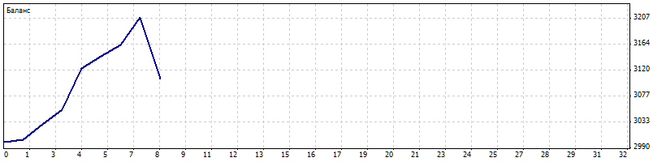
Gross Profit: |  | 209.40 |  | Gross Loss: |  |  |  | 104.00 | Total Net Profit: |  |  | 105.40
Profit Factor: |  | 2.01 |  | Expected Payoff: |  |  |  | 13.18
Absolute Drawdown: |  | 0.00 |  | Maximal Drawdown: |  |  |  | 104.00 (3.24%) | Relative Drawdown: |  |  | 3.24% (104.00)
Total Trades: |  | 8 |  | Short Positions (won %): |  |  |  | 4 (75.00%) | Long Positions (won %): |  |  | 4 (100.00%)
Profit Trades (% of total): |  |  |  |  |  |  |  | 7 (87.50%) | Loss trades (% of total): |  |  | 1 (12.50%)
Largest |  | profit trade: |  |  |  |  |  | 69.40 | loss trade: |  |  | -104.00
Average |  | profit trade: |  |  |  |  |  | 29.91 | loss trade: |  |  | -104.00
Maximum |  | consecutive wins ($): |  |  |  |  |  | 7 (209.40) | consecutive losses ($): |  |  | 1 (-104.00)
Maximal |  | consecutive profit (count): |  |  |  |  |  | 209.40 (7) | consecutive loss (count): |  |  | -104.00 (1)
Average |  | consecutive wins: |  |  |  |  |  | 7 | consecutive losses:

